Cash Advance Request

- Purpose
Cash Advance Requests are creation automatically from MC Registration.

- Views
  - List View
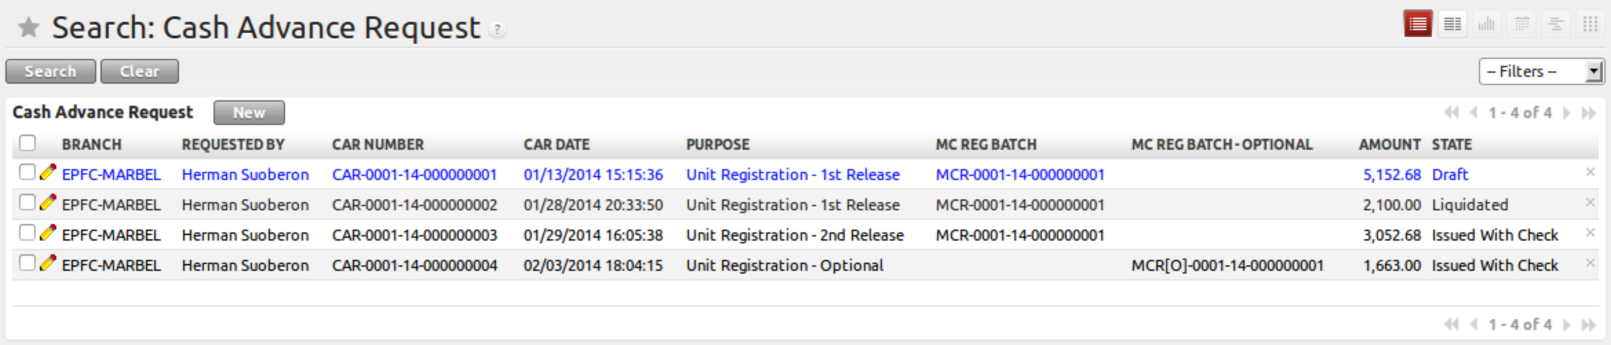
Figure 1. List view of Cash Advance Request

  - Form View
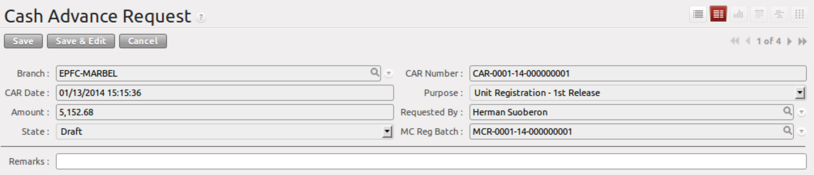
Figure 2. Form view of Cash Advance Request

- Menu and Access Rights
  - Menu – Accounting > Treasury > Cash Advance Request
  - Access Rights
Role | Read | Write | Create | Delete
Budget Officer | Yes | Yes | No | No
Check Disbursement Officer | Yes | Yes | No | No
Payables Clerk | Yes | No | No | No
Loan Processor | Yes | Yes | Yes | No

- Required Fields
All the important fields in this form are already filled out upon automatic creation of records.

- Workflow
Below is the list of states and visibility of the various buttons based on the record state:


Figure 3. Workflow of Cash Advance Request

State | Description | Visible Buttons
Draft | Initial state of the UDR record | N/A
Issued with Check | A cheque has been issued to the requestor; this is automatically set when the Check Voucher record has been confirmed. | N/A
Liquidated | When the Cash Advance request originated from MC Registration, this is automatically set when the MC Registration Liquidation has been confirmed. | N/A

- User Action
All user actions are tied with the following procedures:
- Cash Voucher
- MC Registration
- Petty Cash Fund

- Field Visibility
All Fields are visible.

- Reports and Print Outs
